1. 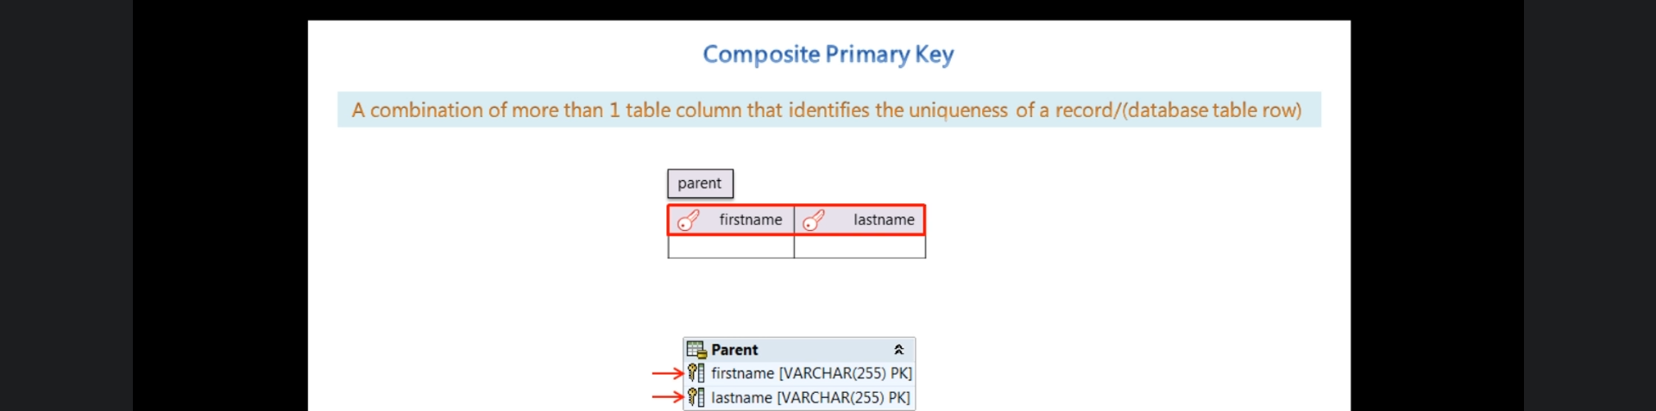
2. 
3. 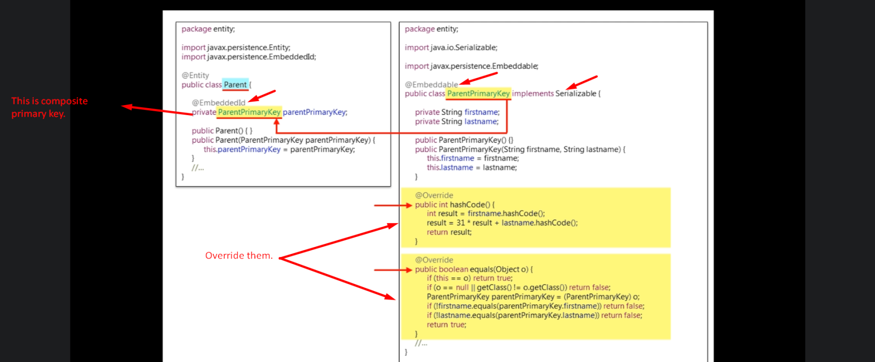
4. 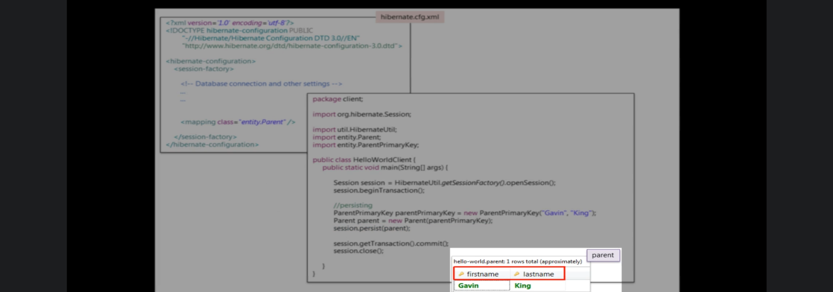
5. 
6. 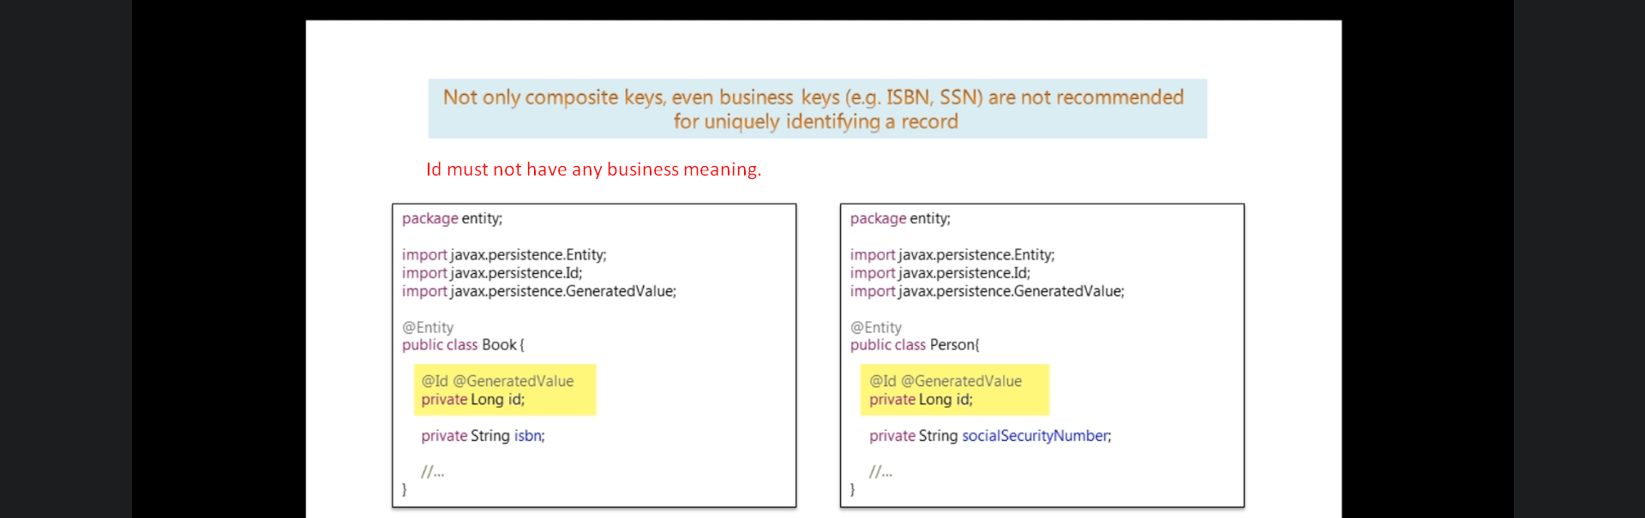
7. 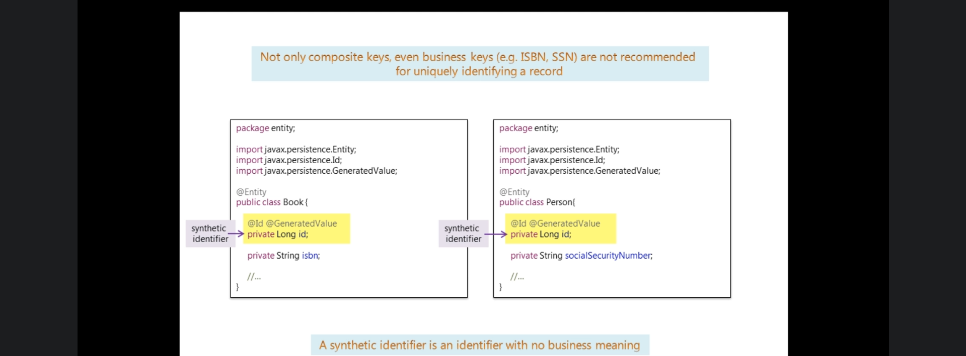
8. 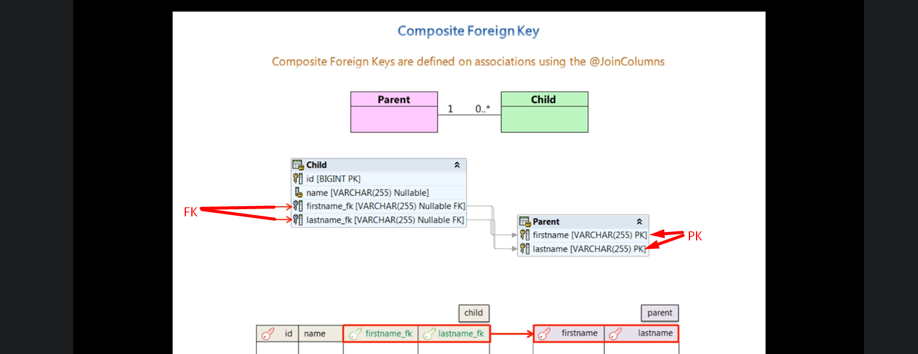
9. 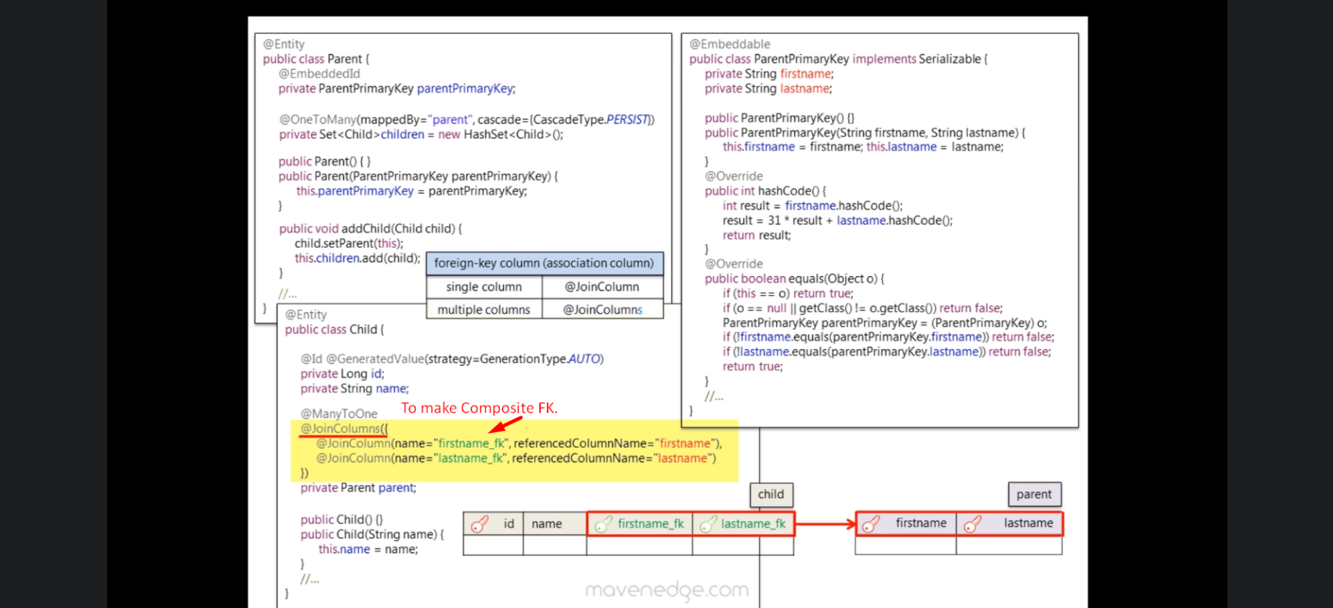**NOTE**: In the above Child class, as per mapping, its table must have 4 columns  
   one for id, one for name and 2 for composite FK (firstname_fk, lastname_fk)
10. 